1. [http://www.jmgroveconstruction.com](http://www.jmgroveconstruction.com/employment.php?view=formbox)
2. Click on Employment link in the footer.
3. Login and register sections are available on the page. A job seeker may apply at jmgrove construction by filling the ‘Employment Application’. An applicant may login to jmgrove application by providing existing username and password.
4. Redirect to “sent successful” or
   1. Autoemail – welcome email template
   2. Username & password autofill, if user selects ok – user is logged apply into app

\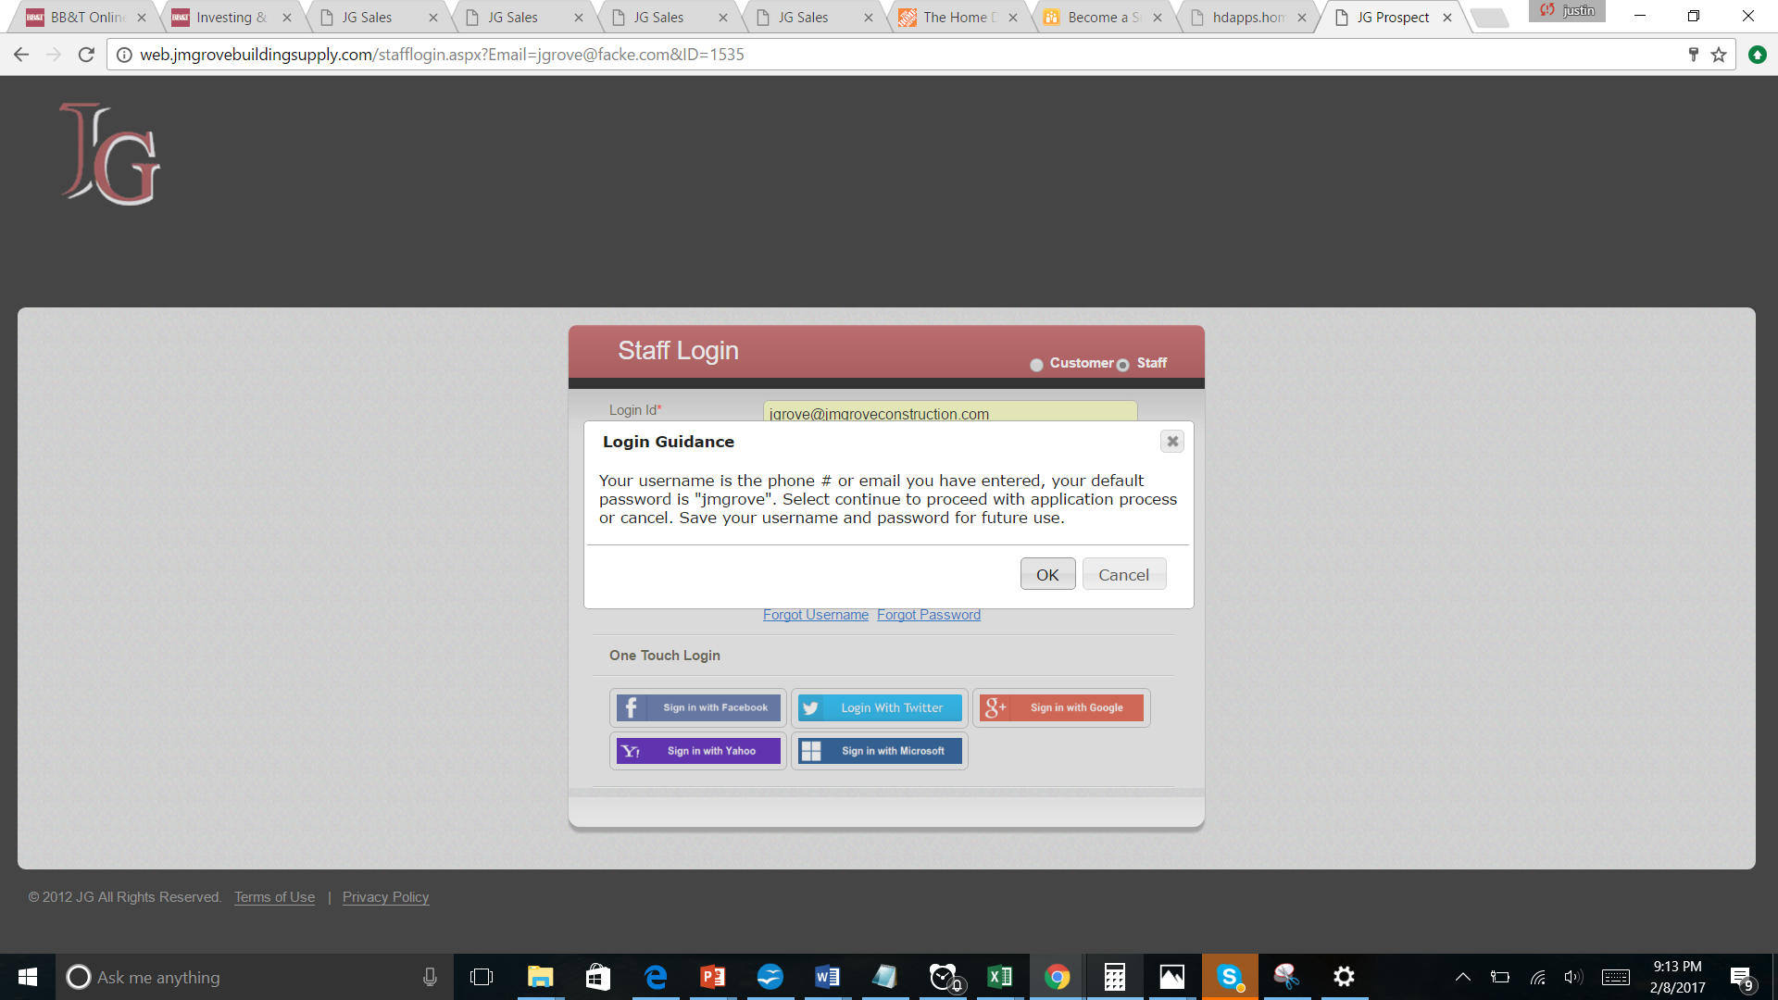

2.)

1) ID# is incorrect 1- Hour

2)Source is not flowing properly - 15mins

3) Added by is incorrect – if JMGC employment form is filled in “added by” = JMGC-PC - 30Mins

3a) Date & Time is slightly off (EST) - 30Mins

4) same email was submitted, this should not be allowed

5.) Country is not flowing

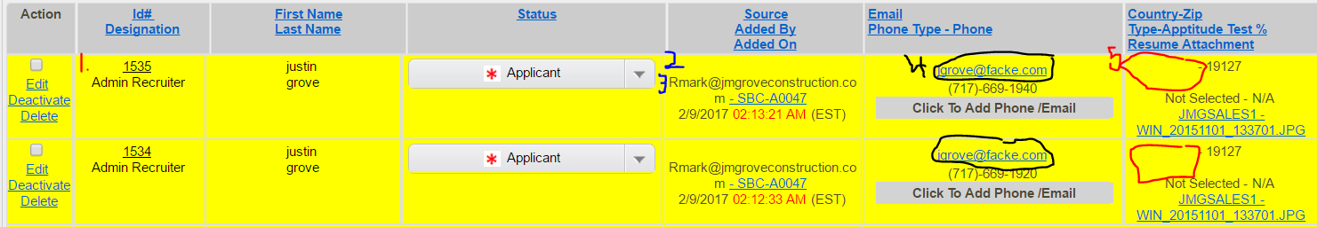

1. This should have a valid ID# - 15min
2. Middle initial fields is not flowing
3. Country not flowing; phone# is not flowing correctly (ex. Missing last 2 digits) -1 Hour (Might require Yogesh during testing)
4. Source is not flowing
5. 5)Employee type is not flowing → Job type:
6. Flow to TPL → Reason for leaving your current job(if applicable)
   1. Flow to TPL → Message to Recruiter:
7. Date& Time is slightly OFF (EST)

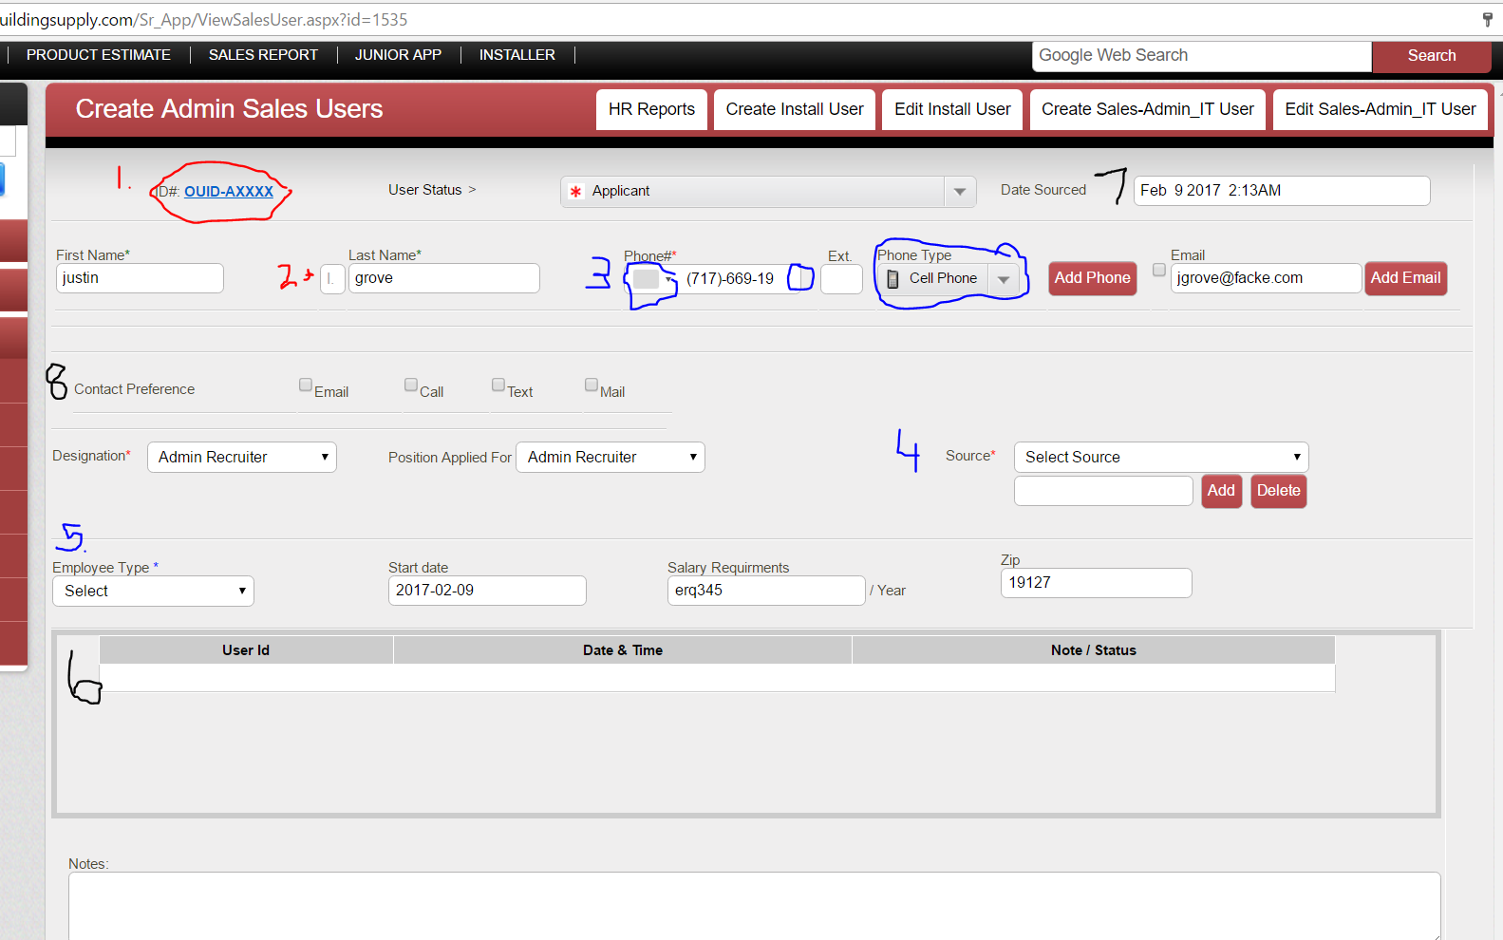

1. Add contact preference to PHP page & make sure flow properly
2. NOT FLOWING -→ Will you be able to pass a drug test and background check?

Yes No

1. NOT FLOWING -→ Have you ever plead guilty to a Felony or been convicted of crime?

Yes No

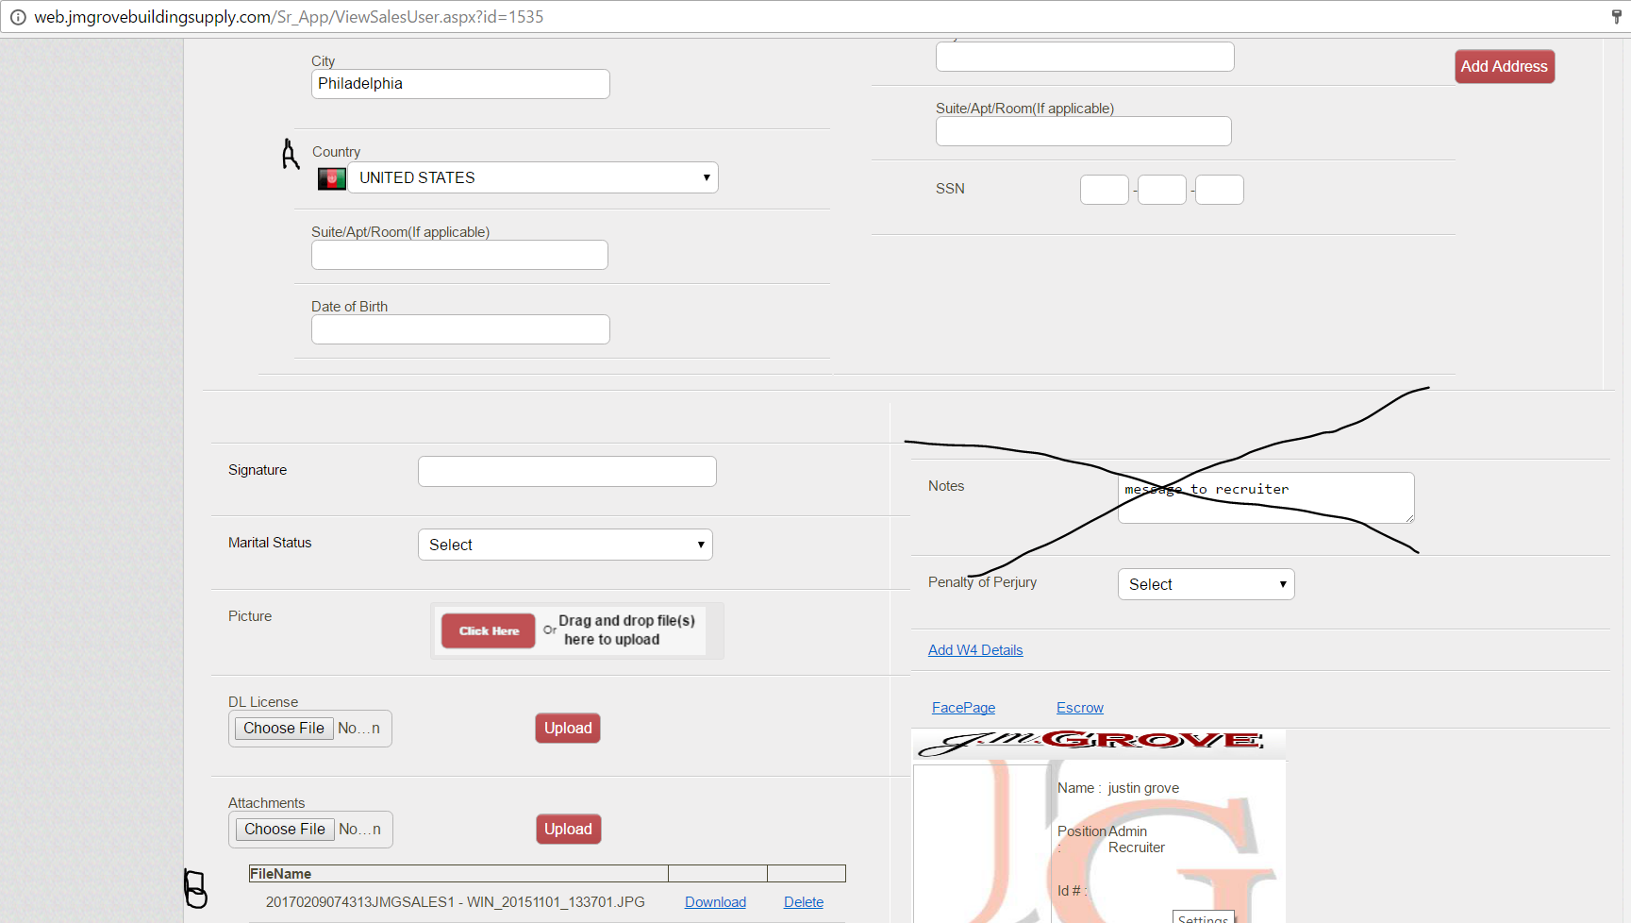

1. Country not flowing correctly
2. Attach resume …is flowing properly, but is not keeping the same file name!! it should

Attach profile picture--- is not flowing (Yogesh), but is not keeping the same file name!! it should